文档编号 | ECSC-DDS 002
文档版本 | 0.1
拟制人 | 陈鹏飞
日期 | 2015.9.1

ECSC云业务管理平台
（工单）
概要设计说明书

变更说明
日期 | 版本 | 变更位置 | 变更说明 | 作者
2015-8-11 | 0.1 | 编写文档 | 新建 | 陈鹏飞
2015-10-27 | 0.1 | Workorder添加字段 | 修改 | 陈鹏飞

目 录
变更说明 2
目 录 3
1 概述 5
1.1 业务分析 5
1.1.1 用例图 5
1.1.2 流程图 7
1.2 定义、缩略语 16
1.3 参考资料 17
2 Form设计 17
2.1 WorkOrder 17
2.2 WorkFlow 17
2.3 WorkOpinion 17
2.4 WorkAccessory 18
3 前台设计 18
3.1 模块规划 18
3.2 客户注册 18
3.2.1 模块描述 19
4 Model设计 20
4.1 BaseWorkOrder 21
4.2 BaseWorkFlow 21
4.3 BaseWorkOpinion 22
4.4 BaseWorkAccessory 22
5 后台设计 22
5.1 类设计 23
5.1.1 模块类图 23
5.1.2 模块类说明 23
5.2 工单基本信息模块 25
5.2.1 控制器(WorkOrderController) 25
5.2.2 业务层(WorkOrderServiceImpl) 27
5.2.3 持久化层(WorkOrderDaoImpl) 32
5.3 工单流程模块 33
5.3.1 控制器(WorkFlowController) 33
5.3.2 业务器(WorkFlowServiceImpl) 34
5.3.3 持久化层(WorkFlowDaoImpl) 35
5.4 工单回复模块 36
5.4.1 控制器(WorkOpinionController) 36
5.4.2 业务器(WorkOpinionServiceImpl) 37
5.4.3 持久化层(WorkOpinionDaoImpl) 38
5.5 工单附件模块(插件未确定，滞留) 38
5.5.1 控制器(WorkAccesspryController) 38
5.5.2 业务器(WorkAccesspryServiceImpl) 38
5.5.3 持久化层(WorkAccesspryDaoImpl) 39
5.6 运维之星 39
5.6.1 控制器(WorkOperationController) 39
5.6.2 业务器(WorkOperationServiceImpl) 39
5.6.3 持久化层(WorkOperationDaoImpl) 40
5.7 短信邮件模块(延用ecmc) 40
5.7.1 WorkSendManageService 40
5.7.2 WorkTimerService(修改) 48

概述

业务分析

用例图
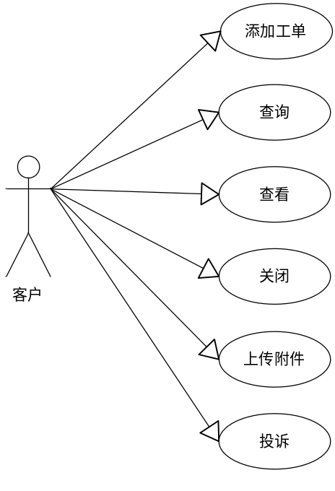

Ecsc客户对工单可进行的操作。
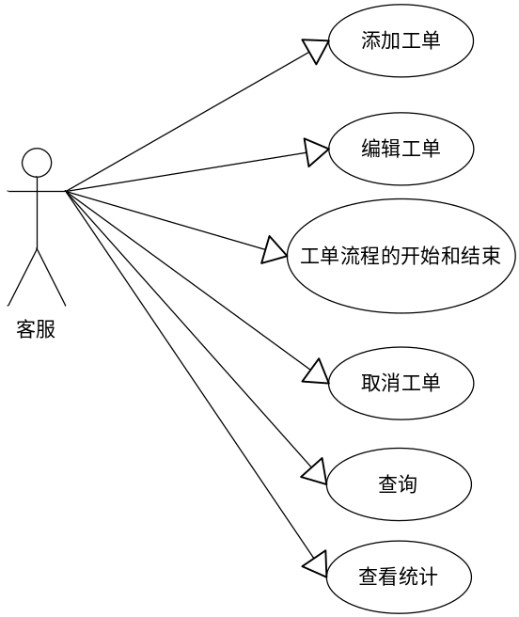
Ecmc客服对工单可进行的操作。
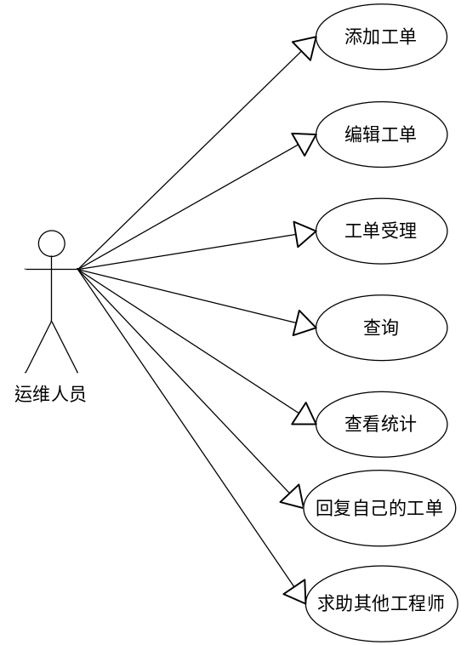
Ecmc运维对工单可进行的操作
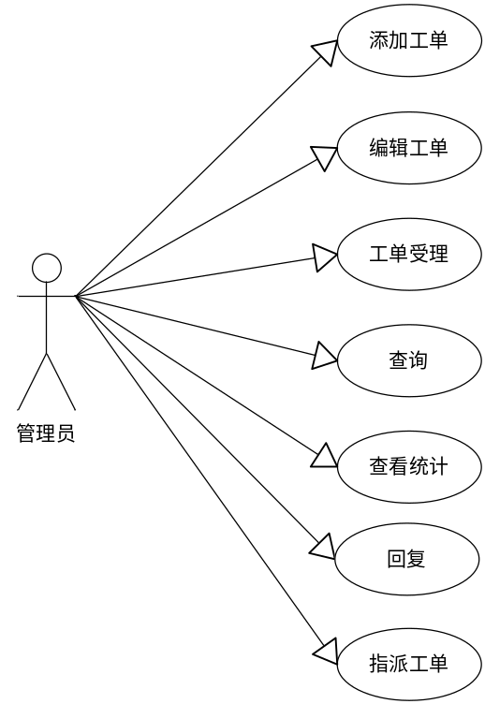
Ecmc管理员对工单可进行的操作。

流程图

ecsc

我的工单
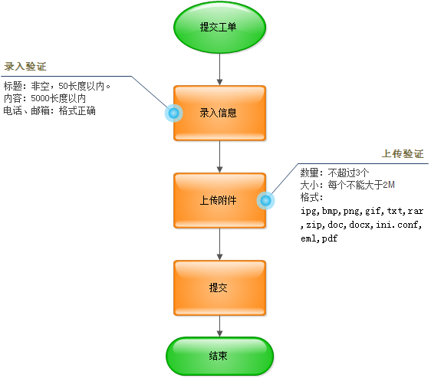

查看指定工单
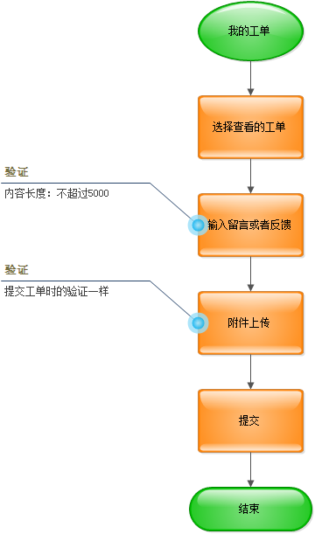

查询工单
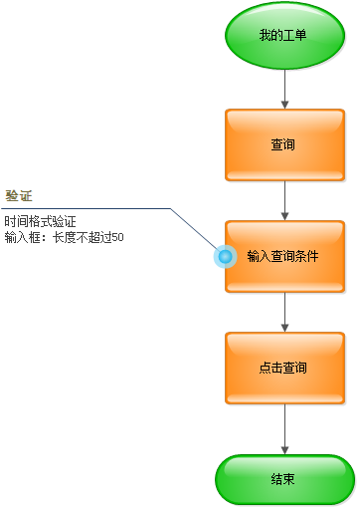

工单关闭
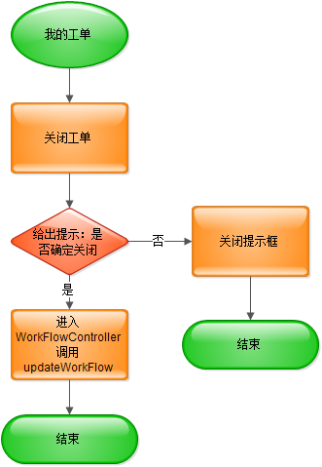

工单删除
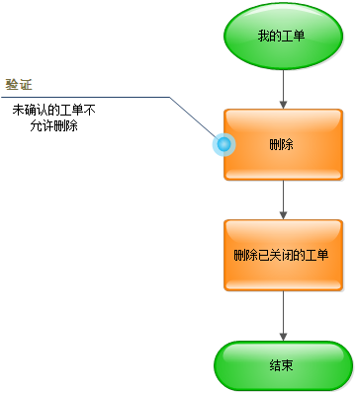

工单投诉
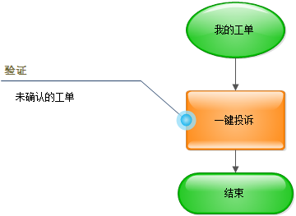

申请注册类工单
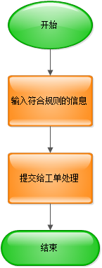

Ecmc

添加工单
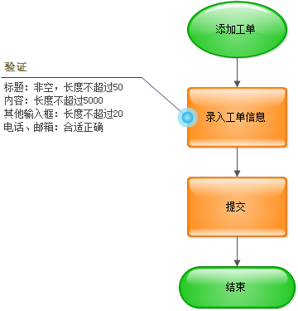

编辑工单
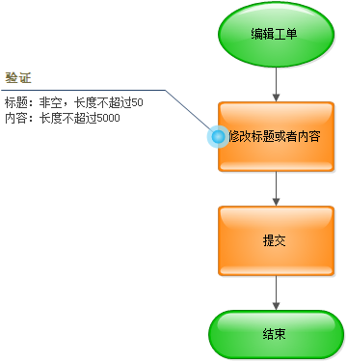

查询工单
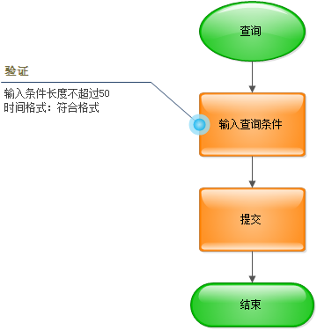

受理工单
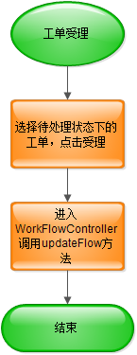

修改工单级别
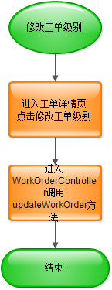

求助其他工程师
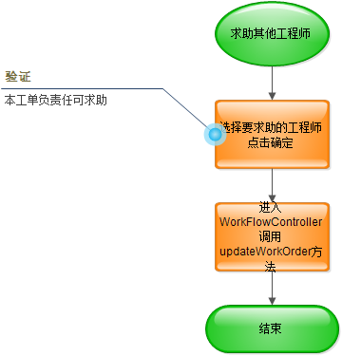

指派其他工程师
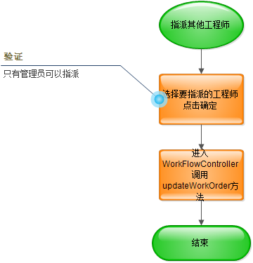

回复
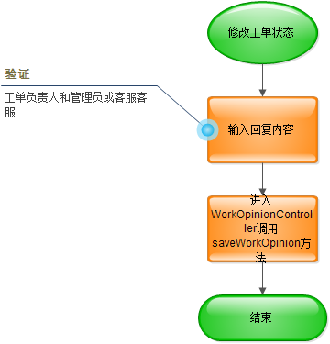

修改工单状态
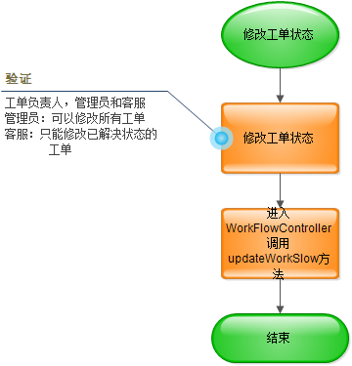

定义、缩略语

参考资料
- 《公有云管理控制台V1.0.0原型2015.08.06》
- 《易云公有云管理控制台V1.0.0需求规格说明书V0.5》

Form设计

WorkOrder

ActionForm标识 | WorkOrder
功能说明： | 继承自BaseWorkOrde字段表
字段类型 | 字段名称 | 字段含义 | 默认值 | 备注
String | workTypeName | 类别名称
String | workLevelName | 级别名称
String | workCreUserName | 创建人名称
String | workCreRoleName | 创建角色名称
String | workApplyRoleName | 申请人名称
String | workPhoneTypeName | 短信提醒时间段
Srting | flowRespondFalg | 工单响应状态
WorkQuota | workQuota | 配额类

WorkFlow
ActionForm标识 | WorkFlow
功能说明： | 继承自BaseWorkFlow字段表
字段类型 | 字段名称 | 字段含义 | 默认值 | 备注
String | headUserName | 负责人名称
String | workOrderName | 工单名称
String | falgName | 状态名称
String | ComplainName | 投诉状态名称
String | SendmagFalgName | 发送短信状态名称
String | StateName | 转办状态名称
String | RespondFalgName | 响应状态名称

WorkOpinion
ActionForm标识 | WorkOpinion
功能说明： | 继承自BaseWorkOpinion字段表
字段类型 | 字段名称 | 字段含义 | 默认值 | 备注
String | userName | 回复者名称 |  | 回复创建者
String | replyUserName | 回复人名称 |  | 给谁回复的

WorkAccessory
ActionForm标识 | WorkAccessory
功能说明： | 继承自BaseWorkAccessory字段表
字段类型 | 字段名称 | 字段含义 | 默认值 | 备注

WorkQuota
ActionForm标识 | BaseWorkQuota
功能说明： | 继承自BaseWorkQuota字段表
字段类型 | 字段名称 | 字段含义 | 默认值 | 备注

前台设计

模块规划
菜单资源 | Controller类名 | Web目录 | 备注
工单管理 | WorkOrderController | /app/work_order/*.html | 录入工单信息，可以上传附件，查看，投诉，关闭，删除工单。

客户注册

模块描述

提交工单
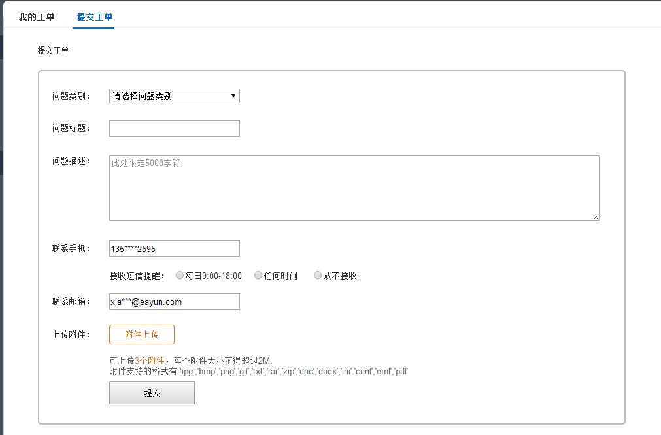
录入规则：
标题：长度不得超过50，非空
描述：长度不得超过5000。
联系手机，邮箱：符合规格。
附件：不得超过3个，每个大小不得超过2M，支持ipg,bmp,png,gif,txt,rar,zip,doc,docx,ini.conf,eml,pdf格式。

我的工单
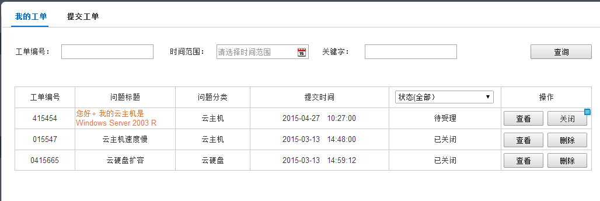
输入查询条件点击查询，显示符合查询结果的。
点击查看
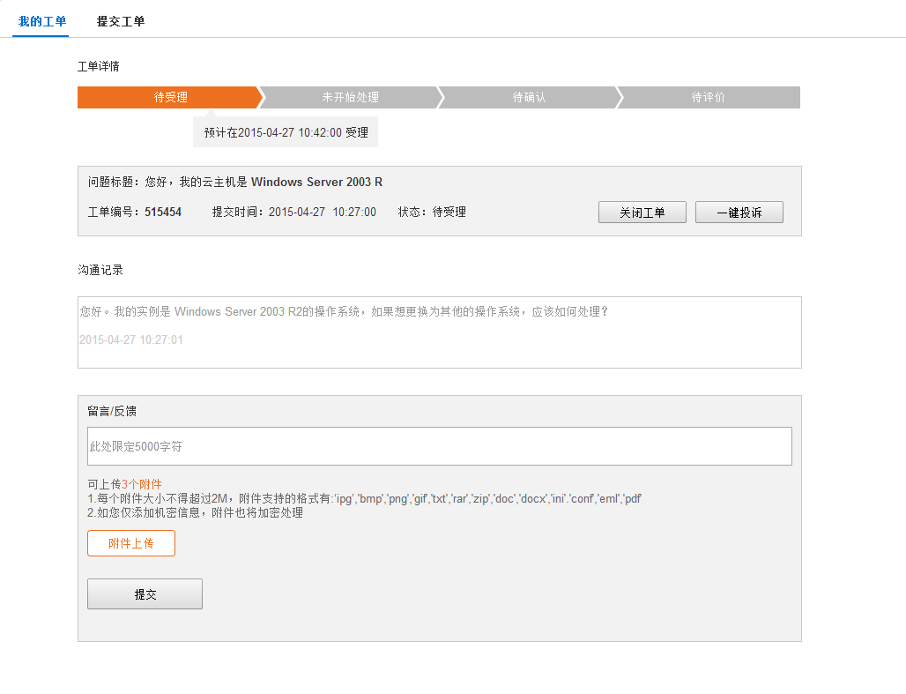
显示工单的处理流程，基本信息沟通记录

工单处理完成后可以关闭。

客户不满意可一键投诉。

Model设计

BaseWorkOrder
ActionForm标识 | BaseWorkOrder
功能说明： | 继承自work_order字段表
字段类型 | 字段名称 | 字段含义 | 默认值 | 备注
String | workId | ID
String | workNum | 工单编号
String | workTitle | 工单标题
String | workContent | 工单内容
String | workType | 工单类别
String | workLevel | 工单级别
String | workCreUser | 工单创建人
String | workCreRole | 创建工单角色
String | workApplyUser | 工单申请人
Date | workCreDate | 工单创建时间
String | workPhone | 联系电话
String | workPhoneTime | 接受短信提醒时间段
String | workEmail | 联系邮箱
String | flowId | 工单当前流程

BaseWorkFlow
ActionForm标识 | BaseWorkFlow
功能说明： | 继承自work_flow字段表
字段类型 | 字段名称 | 字段含义 | 默认值 | 备注
String | flowId | ID
String | workId | 工单id
String | userIdHead | 工单负责人
String | flowFlag | 工单状态
String | flowComplain | 投诉状态
String | flowSendmagFalg | 发送短信状态 | 1
String | flowState | 转办状态
String | flowRespondFalg | 响应状态
Date | flowBeginTime | 开始时间
Date | flowRespondTime | 响应时间
Date | flowEndTime | 结束时间

BaseWorkOpinion
ActionForm标识 | BaseWorkOpinion
功能说明： | 继承自work_opinion字段表
字段类型 | 字段名称 | 字段含义 | 默认值 | 备注
String | opinionId | ID
String | workId | 工单id
String | opinionContent | 回复内容
Date | opinionTime | 回复时间
String | opinionUser | 回复者 |  | 回复内容创建者
String | replyUser | 回复人 |  | 回复给谁的

BaseWorkAccessory
ActionForm标识 | BaseWorkAccessory
功能说明： | 继承自work_accessory字段表
字段类型 | 字段名称 | 字段含义 | 默认值 | 备注
String | saccId | ID
String | workId | 工单id
Integer | saccSize | 附件大小
String | saccNameShow | 附件显示名称
String | saccName | 附件真实名称
String | saccType | 附件类型
String | saccUrl | 附件地址

BaseWorkQuota
ActionForm标识 | BaseWorkQuota
功能说明： | 继承自work_quota字段表
字段类型 | 字段名称 | 字段含义 | 默认值 | 备注
String | work_id | 工单id
Integer | quota_vm | 云主机配额
Integer | quota_cpu | Cpu配额
float | quota_memory | 内存配额
Integer | quota_disk | 云硬盘配额
Integer | quota_Snapshot | 云快照配额
float | quota_diskshot | 云硬盘和快照配额
float | quota_band | 带宽配额(Mbps)
Integer | quota_vpn | vpn配额
Integer | quota_net | 网络配额
Integer | quota_subnet | 子网配额
Integer | quota_firewall | 防火墙配额
Integer | quota_route | 路由配额
Integer | quota_secGroup | 安全组配额
Integer | quota_floatIp | 浮动Ip配额
Integer | quota_balance | 负载均衡配额
String | prj_id | 项目id

后台设计

类设计

模块类图
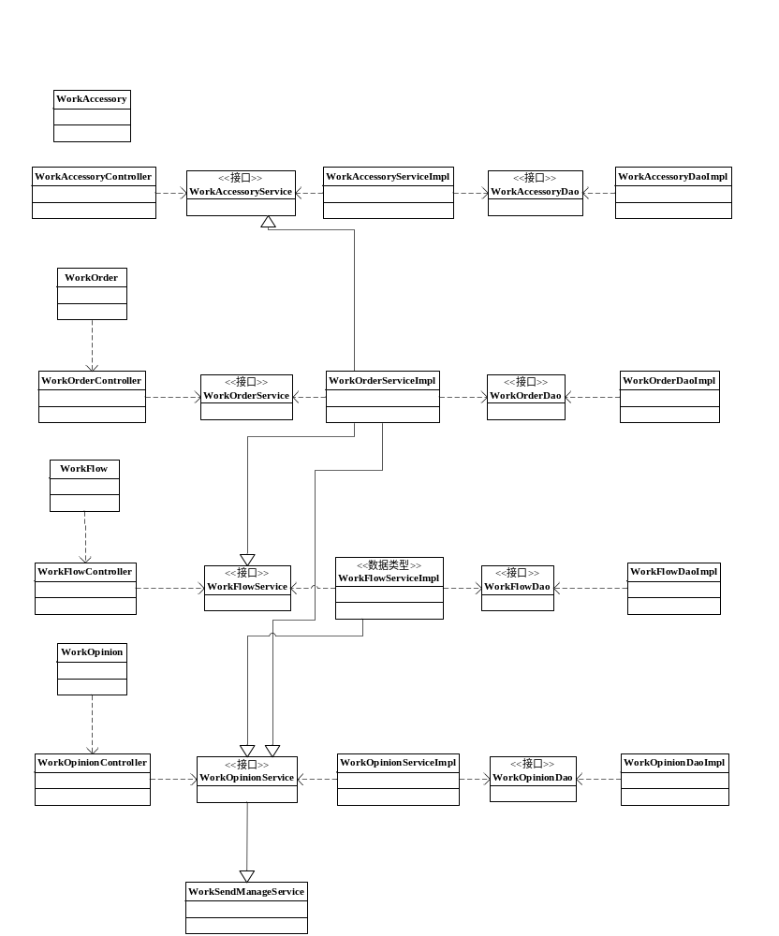

模块类说明
类名 | 包名 | 说明 | 描述
WorkOrderController | com.eayun.work.workOrder.controller | 工单信息模块控制器
WorkOrderServicel | com.eayun.work.workOrder.service | 工单信息模块业务接口
WorkOrderServiceImpl | com.eayun.work.workOrder.service | 工单信息模块业务实现 | 实现WorkOrderServicel
WorkOrderDao | com.eayun.work.workOrder.dao | 工单信息模块持久化层接口
WorkOrderDaoImpl | com.eayun.work.workOrder.dao | 工单信息模块持久化层实现 | 实现WorkOrderDao
WorkFlowController | com.eayun.work.workFlow.controller | 工单流程控制器
WorkFlowService | com.eayun.work.workFlow.service | 工单流程业务接口
WorkFlowServiceImpl | com.eayun.work.workFlow.service | 工单流程业务实现 | 实现WorkFlowService
WorkFlowDao | com.eayun.work.workFlow.dao | 工单流程持久化层接口
WorkFlowDaoImpl | com.eayun.work.workFlow.dao | 工单流程持久化层实现 | 实现WorkFlowDao
WorkOpinionController | com.eayun.work.workOpinion.controller | 工单回复控制器
WorkOpinionService | com.eayun.work.workOpinion.service | 工单回复业务接口
WorkOpinionServiceImpl | com.eayun.work.workOpinion.service | 工单回复业务实现 | 实现WorkOpinionService
WorkOpinionDao | com.eayun.workOpinion.dao | 工单回复持久化层接口
WorkOpinionDaoImpl | com.eayun.work.workOpinion.dao | 工单回复持久化层实现 | 实现WorkOpinionDao
WorkAccesspryController | com.eayun.work.workAccesspry.controller | 工单附件控制器
WorkAccesspryService | com.eayun.workAccesspry.service | 工单附件业务接口
WorkAccesspryServiceImpl | com.eayun.work.workAccesspry.service | 工单附件业务实现 | 实现WorkAccesspryService
WorkAccesspryDao | com.eayun.work.workAccesspry.dao | 工单附件持久化层接口
WorkAccesspryDaoImpl | com.eayun.workAccesspry.dao | 工单附件持久化层实现 | 实现WorkAccesspryDao
WorkOperationController | com.eayun.workOperation.controller | 运维之星控制器
WorkOperationService | com.eayun.workOperation.service | 运维之星业务接口
WorkOperationServiceImpl | com.eayun.workOperation.service | 运维之星业务实现 | 实现WorkOperationService
WorkOperationDao | com.eayun.workOperation.dao | 运维之星持久化层接口
WorkOperationDaoImpl | com.eayun.workOperation.dao | 运维之星持久化层实现 | 实现WorkOperationDao
WorkSendManageService | Com.eayun.util.workSendManage | 发送短信
WorkTimerService | Com.eayun.util.workTimer | 发送短信定时

工单基本信息模块

控制器(WorkOrderController)
@controller
@RequestMapping("/sys/workOrder")
public class WorkOrderController{
@Autowired
private WorkOrderService workOrderService;

}

saveWorkOrder
@ResponseBody
@RequestMapping("/saveWorkOrder")
public void saveWorkOrder(WorkOrder workOrder,HttpServletRequest request){
workOrderService.saveworkOrder(workOrder);
//添加成功后

}

findOneWorkOrder
@ResponseBody
@RequestMapping("/findOneWorkOrder")
public void findOneWorkOrder(WorkOrder workOrder,HttpServletRequest request){
//获取参数
workOrderService.findOneWorkOrder(workId,workLevel);
}

getWorkorderList
/**
* 查询未完成工单
**/
@ResponseBody
@RequestMapping("/findWorkOrder")
public void getWorkorderList(WorkOrder workOrder,HttpServletRequest request){
//获取查询别

workOrderService.findWorkOrder(workOrder);
}

业务层(WorkOrderServiceImpl)
@service
public class WorkOrderServiceImpl implements WorkOrderService{
@Autowired
private WorkOrderDao workOrderDao;
@Autowired
private WorkFlowService workFlowService;
@Autowired
private WorkOpinionService workOpinionService;

}

saveWorkOrder
public void saveWorkOrder(WorkOrder workOrder，WorkQuota workQuota){
workOrderDao.saveWorkOrder(workOrder);
If(判断工单类型 是申请配额工单 和workQuota！=null){
this.saveWorkOrderQuota
}
//成功
workFlowService.saveWorkFlow(workOrder);
//添加回复
//添加附件
}

saveWorkOrderQuota
public void saveWorkOrder(WorkQuota workQuota){
转换成baseWorkQuota
调用dao层添加

}

findOneWorkOrder
@ResponseBody
@RequestMapping("/findOneWorkOrder")
public void findOneWorkOrder(WorkOrder workOrder){
//获取参数
workOrderService.findOneWorkOrder(workId,workLevel);
If(工单类型是申请配额){
查询工单多申请的配额
}

}

getWorkorderList(查询未完成工单)
@ResponseBody
@RequestMapping("/updateWorkOrder")
public void getWorkorderList(Map<String,String> map){
String hql = “”;
条件判断
workorderDao.find(hql mvalue);
}

工单流程模块

控制器(WorkFlowController)
@controller
@RequestMapping("/sys/workFlow")
public class WorkOrderController{
@Autowired
private WorkFlowService workFlowService;
}

saveWorkFlow
public void saveWorkFlow(WorkOrder workOrder,HttpServletRequest request){
workFlowService.saveWorkFlow(workOrder);
}

updateWorkFlow
public void updateWorkFlow(WorkOrder workOrder,HttpServletRequest request){
//获取参数
workFlowService.updateWorkFlow(workOrder);

}

findWorkFlowByWorkId
public List<WorkFlow> findWorkFlowByWorkId(String sql){
//获取参数
List<WorkFlow> flowList=workFlowService.findWorkFlowByWorkId(workId);
return flowList;
}

业务器(WorkFlowServiceImpl)
@service
public class WorkFlowServiceImpl implements WorkFlowService{
@Autowired
private WorkFlowDao workFlowDao ;
@Autowired
private WorkOpinionDao workOpinionService ;

}

saveWorkFlow
public void saveWorkFlow(WorkOrder workOrder){
//根据workOrder拼装workFlow
workFlowDao .saveWorkFlow(workFlow);
//添加回复
workOpinionService .saveworkOpinion(workOrder,workFlow);

}

updateWorkFlow
public void updateWorkFlow(WorkOrder workOrder,WorkFlow workFlow){
//获取旧工单流程
//把新工单的可编辑数据导入到旧工单中。
//判断流程状态是否更改
if(oldWorkFlow.getWorkFalg() != workFlow.getWorkFalg() || workFlow.getWorkState() ==1){
//状态改变或者转办
在oldWorkFlow中导入workFlow
}
if(oldWorkFlow.getBeginTime()==null && oldWorkFlow.getWorkFalg()==1){//第一次受理
oldWorkFlow.setBeginTime(new Date());
}
//结束时间特殊化
if(oldWorkFlow.getEndTime()==null && (oldWorkFlow.getWorkFalg()==2|| oldWorkFlow.getWorkState()==null)){//第一次解决或者转办
oldWorkFlow.setEndTime(new Date());
}
if(oldWorkFlow.getRespondTime()==null && oldWorkFlow.getWorkFalg()==1){//第一次响应
oldWorkFlow.setRespondTime(new Date());
}
workFlowDao .updateWorkFlow(导入后的工单);
//添加回复
workOpinionService .saveworkOpinion(workOrder,workFlow,null);

}

findWorkFlowByWorkId

private List<WorkFlow> findWorkFlowByWorkId(String workId){
String sql = ”from WorkFlow where workId=’”+workId+”’”;
List<WorkFlow> flowList=workOrderService.findWorkFlowByWorkId(sql);
return flowList;
}

持久化层(WorkFlowDaoImpl)
@service
public class WorkFlowDaoImpl implements WorkFlowDao{
}

saveWorkFlow
public void saveWorkFlow(WorkFlow workFlow){
this.getHibernateTemplate().save(workFlow);
}

updateWorkFlow
public void updateWorkFlow(WorkFlow workFlow){
this.getHibernateTemplate().update(workFlow);
}

findWorkFlowBySql
public List<WorkFlow> findWorkFlowByFalg(String sql){
List<WorkFlow> flowList=this.getHibernateTemplate().find(sql);
return flowList
}

工单回复模块

控制器(WorkOpinionController)
@controller
@RequestMapping("/sys/workOpinion")
public class WorkOpinionController{
@Autowired
private WorkOpinionService workOpinionService ;
}

saveWorkOpinion
public void saveWorkOpinion(WorkOpinion workOpinion,WorkFlow workflow,HttpServletRequest request){
//获取参数
workOpinionService .saveworkOpinion(workOrder,workFlow);
}

findWorkOpinionByWorkId
public List<WorkOpinion> findworkOpinionByWorkId(String workId){
//获取参数
List<WorkOpinion> flowList=workOpinionService .findWorkOpinionByWorkId(workId);
return flowList;
}

业务器(WorkOpinionServiceImpl)
@service
public class WorkOrderServiceImpl implements WorkOrderService{
@Autowired
private WorkOrderDao workOrderDao;
@Autowired
private WorkSendManageService sendservice;

}

saveWorkOpinion
public void saveWorkOpinion(WorkOrder workOrder,WorkFlow workFlow,String type){
//根据workOrder和workFlow拼装回复
workFlowService.saveWorkOpinion(workOpinion);
// 发送邮件或短信
if(type==edit){
//编辑工单
sendservice.sendMessageForEdit(workOrderVoe,workOpinion,roleId,userId);
}else{
sendservice.sendMessage(workOrder, workOpinion);
}
}

findWorkOpinionByWorkId
public List<WorkFlow> findWorkOpinionByWorkId(String workId){
String sql=”from WorkFlow where WorkId=’”+workId+”’”;
List<WorkFlow> flowList=workFlowService.findWorkOpinionByWorkId(workId);
return flowList;
}

持久化层(WorkOpinionDaoImpl)
@service
public class WorkOpinionDaoImpl implements WorkOpinionDao{
}

saveWorkOpinion
public void saveWorkOpinion(WorkOpinion workOpinion){
this.getHibernateTemplate().save(workOpinion);
}

findWorkOpinionBySql
public List<WorkOpinion> findWorkOpinionByFalg(String sql){
List<WorkOpinion> flowList=this.getHibernateTemplate().find(sql);
return flowList;
}

工单附件模块(插件未确定，滞留，ecsc)

控制器(WorkAccessoryController)
@controller
@RequestMapping("/sys/workAccesspry")
public class WorkOrderController{
@Autowired
private WorkOrderService workOrderService;
}

saveWorkAccessory
@ResponseBody
@RequestMapping("/saveWorkAccessory")
public String saveWorkAccessory(WorkAccessory workAccessory,HttpServletRequest request){
//获取上传插件的参数
//放入workAccessory中
workOrderService.saveWorkAccessory(workAccessory);
}

deleteWorkAccessory
@ResponseBody
@RequestMapping("/deleteWorkAccessory")
public String deleteWorkAccessory(WorkAccessory workAccessory,HttpServletRequest request){
//获取上传插件的参数
//放入workAccessory中
workOrderService.deleteWorkAccessory(workAccessory);
}

业务器(WorkAccessoryServiceImpl)
@service
public class WorkOrderServiceImpl implements WorkOrderService{
@Autowired
private WorkOrderDao workOrderDao;

}

saveWorkAccessory
public String saveWorkAccessory(WorkAccessory workAccessory,HttpServletRequest request){
//获取上传插件的参数
//判断附件数量，超过3个，返回，提示附件超出数量
//否则根据工单id查询工单已有附件数量
Int con=已有数+上传数
//如果 con大于3 提示，附件数超出，先删除原有附件
//否则新上传的放入workAccessory中
//循环添加
workOrderDao.saveWorkAccessory(workAccessory);
//数据库添加成功后
//插件写入本地
}

deleteWorkAccessory
public String deleteWorkAccessory(WorkAccessory workAccessory,HttpServletRequest request){
//获取上传插件的参数
//放入workAccessory中
workOrderService.deleteWorkAccessory(workAccessory);
//数据库删除成功后
//插件删除本地
}

持久化层(WorkAccessoryDaoImpl)
@service
public class WorkOrderDaoImpl implements WorkOrderDao{
}

saveWorkAccessory
public String saveWorkAccessory(WorkAccessory workAccessory,HttpServletRequest request){
this.getHibernateTemplate().save(workAccessory);
}

deleteWorkAccessory
public String deleteWorkAccessory(WorkAccessory workAccessory){
this.getHibernateTemplate().delete(workAccessory);
}

运维之星(ecmc,未变动)

控制器(WorkOrderManageReportControllrt)
@controller
@RequestMapping("/sys/workAccesspry")
public class WorkOrderController{
@Autowired
private WorkOrderService workOrderService;
}

业务器(WorkOrderManageReportService)
@service
public class WorkOrderServiceImpl implements WorkOrderService{
@Autowired
private WorkOrderDao workOrderDao;
@Autowired
private UserService userservice;
@Autowired
private SysUserDao udao;

}

短信邮件模块(延用ecmc)

WorkSendManageService
publiC class WorkSendManageService extends quartzJobBean{
@Autowired
private WorkOrderService workOrderService;
}
}

sendEmailMessage(发送邮件)
private void sendEmailMessage(WorkOrder workOrder, WorkOpinion workOpinion, List<String> emailList,JSONObject role) throws AppException{
SysUser replyuser = userService.getUserByUserId(workOpinion.getReplyUser());//回复人
SysUser creuser = userService.getUserByUserId(workOrder.getCreUser());// 工单起草、关闭人

StringBuffer strb =content(role, workOrder, workOpinion, replyuser, creuser);
MailSendThread mst = new MailSendThread();//邮件类
mst.setTitle(workOrder.getTitle());
mst.setContent(strb.toString());
emailList.add(creuser.getUserMail());
mst.setEmail(emailList);
new Thread(mst).start();
}

content（拼接发送内容）
private StringBuffer content(JSONObject role,WorkOrder workOrder,WorkOpinion workOpinion,SysUser replyuser,SysUser creuser){
StringBuffer content = new StringBuffer();
content.append("工单编号:" + workOrder.getOrderNum() + ",\n工单标题为:" + workOrder.getTitle()+"\n");//发送内容
if (!"0".equals(workOrder.getFlag())) {// 工单状态不等于0的情况下走这个
if (FalgObject.ESQ.equals(role.get("roleId"))) {
content.append("客服人员");
} else {
content.append("工单负责人");
}
} else {// 工单状态等于“ 0 待处理”的情况下 给所有的运维工程师和管理员发送邮件
content.append(role.get("roleName"));
}
if(replyuser.getUserName().equals(creuser.getUserName())){//回复人等于创建人
content.append(":"+replyuser.getUserName()+"\n" + workOpinion.getOpinionContent());
}else{
content.append(":"+replyuser.getUserName() +" 告知 " + creuser.getUserName() + "\n" + workOpinion.getOpinionContent());
}
return content;
}

sendSmsMessage（发送短信）
private void sendSmsMessage(WorkOrder workOrder, WorkOpinion workOpinion, String phone,JSONObject role) throws AppException {
SysUser replyuser = userService.getUserByUserId(workOpinion.getReplyUser());// 工单负责人
SysUser creuser = userService.getUserByUserId(workOpinion.getCreUserId());// 工单起草、关闭人

StringBuffer content = content(role, workOrder, workOpinion, replyuser, creuser);
SMSSendThread sms = new SMSSendThread();
sms.setPhone(phone);
sms.setContent(content.toString());
new Thread(sms).start();
}

snedMessageToUser
private void sendMessageToUser(WorkOrder workOrder, WorkOpinion workOpinion,String userId,JSONObject role) throws AppException{
SendEmailMessageVOE sendMessageVoe = queryUserById(userId);// 取得创建者 邮箱和手机号
if(!workOpinion.getReplyUser().equals(workOrder.getCreUser())){//当前回复人不是创建者

if (!"".equals(sendMessageVoe.getPhone()) && sendMessageVoe.getPhone() != null) {//手机号码不为空发送短信
sendSMSMessage(workOrder, workOpinion, sendMessageVoe.getPhone(),role);
}
List<String> emailList = new ArrayList<String>();
if(sendMessageVoe.getEmail()!=null && !"".equals(sendMessageVoe.getEmail())){
emailList.add(sendMessageVoe.getEmail());
sendEmailMessage(workOrder, workOpinion, emailList,role);
}
}
}

sendMessageToAdmin
private void sendMessageToAdmin(WorkOrder workOrder, WorkOpinion workOpinion,String userId,JSONObject role) throws AppException{
List<SendEmailMessageVOE> sendList =queryAdminByUser(userId);
List<String> emailList =new ArrayList<String>();
for (SendEmailMessageVOE sendMessageVoe : sendList) {
if (!"".equals(sendMessageVoe.getPhone()) && sendMessageVoe.getPhone() != null) {//手机号码不为空发送短信
sendSMSMessage(workOrder, workOpinion, sendMessageVoe.getPhone(),role);
}
if(sendMessageVoe.getEmail()!=null && !"".equals(sendMessageVoe.getEmail())){
emailList.add(sendMessageVoe.getEmail());
}
}
if (emailList!=null && emailList.size()>0) {
sendEmailMessage(workOrder, workOpinion, emailList,role);
}
}

findRoleForUser
private JSONObject findRoleForUser(String userId){
StringBuffer strb = new StringBuffer();
strb.append("select sr.id ,sr.rolename from sys_role sr");
strb.append(" left join userrole ur on sr.id = ur.roleid");
strb.append(" left join sys_user su on su.user_id = ur.operid");
strb.append(" where su.user_id ='"+userId+"'");
CachedRowSet crs = DBAccess.getDBTool().querySql(strb.toString());
JSONObject jsonObject = new JSONObject();
try {
while (crs != null && crs.next()) {
jsonObject.put("roleId", JUtilities.getString(crs, "id"));
jsonObject.put("roleName", JUtilities.getString(crs, "rolename"));
}
} catch (SQLException e) {
// TODO Auto-generated catch block
e.printStackTrace();
}
return jsonObject;
}

queryUserById(修改)
private SendEmailMessageVOE queryUserById(String userId，WorkOrder workOrder) {
String from ="sys_user";
if(workOrder.getWorkCreRole()==2){//ecsc
from ="sys_selfuser";
}
String sql = "select t.user_name,t.user_mobile,t.user_mail from " + from +" t where t.user_id='" + userId + "'";
CachedRowSet crs = DBAccess.getDBTool().querySql(sql);
SendEmailMessageVOE sendMessageVoe=null;
try {

while (crs != null && crs.next()) {
sendMessageVoe = new SendEmailMessageVOE();
sendMessageVoe.setUserId(JUtilities.getString(crs, "user_id"));
sendMessageVoe.setUserName(JUtilities.getString(crs, "user_name"));
sendMessageVoe.setPhone(JUtilities.getString(crs, "user_mobile"));
sendMessageVoe.setEmail(JUtilities.getString(crs, "user_mail"));
}

} catch (SQLException e) {
e.printStackTrace();
}
return sendMessageVoe;
}

queryAdminByUser
private List<SendEmailMessageVOE> queryAdminByUser(String userId) {
List<SendEmailMessageVOE> list = new ArrayList<SendEmailMessageVOE>();
StringBuffer strb = new StringBuffer();
strb.append("select su.user_name,su.user_mobile,su.user_mail , su.user_id from sys_user su , userrole ur ,sys_role sr");
strb.append(" where (sr.id ='"+FalgObject.ADMIN+"' or sr.id = '"+FalgObject.CPIS+"')");
strb.append(" and su.user_id !='"+userId+"' group by su.user_id");
CachedRowSet crs = DBAccess.getDBTool().querySql(strb.toString());
try {
while (crs != null && crs.next()) {
SendEmailMessageVOE voe = new SendEmailMessageVOE();
voe.setUserId(JUtilities.getString(crs, "user_id"));
voe.setUserName(JUtilities.getString(crs, "user_name"));
voe.setPhone(JUtilities.getString(crs, "user_mobile"));
voe.setEmail(JUtilities.getString(crs, "user_mail"));
list.add(voe);
}
} catch (SQLException e) {
e.printStackTrace();
}
return list;
}

sendMessageForOpinion(回复时发送的邮件)
public void sendMessageForOpinion(WorkOrder workOrder, WorkOpinion workOpinion) throws AppException {
JSONObject role = findRoleForUser(workOpinion.getReplyUser());//获取回复人的角色
if (!"0".equals(workOrder.getFlag())) {
// '运维工程师/管理员'和'客服人员'回复工单时 发送邮件或短信（给创建人、负责人和所有管理员排除当前操作人）
//给创建人发送邮件，如果回复人不是创建人
if(!workOpinion.getReplyUser().equals(workOrder.getCreUser())){
sendMessageToCreUser(workOrder, workOpinion, workOrder.getCreUser(),role);
}
//给负责人发送邮件和短信，如果负责人是回复人，则不会给创建人本人发送邮件
if(!workOrder.getHeadUser().equals(workOpinion.getReplyUser())){
sendMessageToCreUser(workOrder, workOpinion, workOpinion.getReplyUser(),role);
}
//给所有管理员发送邮件，如果回复者是管理员，则不给回复者发邮件
if(!workOpinion.getReplyUser().equals(FalgObject.ADMIN)){
sendMessageToAdmin(workOrder, workOpinion, workOpinion.getReplyUser(),role);
}
} else { // 客服人员新建工单是 默认给'运维工程师'和'管理员' 发送邮件或短信
// 创建者也会收到邮件（记录）
sendMessageToCreUser(workOrder, workOpinion, workOrder.getCreUser(),role);
// 排除运维工程师或者管理员自己给自己发送邮件
sendMessageToAdmin(workOrder, workOpinion, workOpinion.getReplyUser(),role);
}
}

sendMessageForEdit(编辑时发送邮件)
public void sendMessageForEdit(WorkOrderVoe workOrderVoe, WorkOpinion info, String role,String userId) throws Exception {
List<String> mails = new ArrayList<String>();
try {
// 创建者如果不是当前操作人，则会收到邮件
SendEmailMessageVOE creUserInfo = queryUserById(workOrderVoe.getCreUser());
if (!"".equals(creUserInfo.getPhone()) && creUserInfo.getPhone() != null) {
sendSMSMessageForEdit(workOrderVoe, creUserInfo.getPhone());
}
mails.add(creUserInfo.getEmail());
//负责人如果不是当前操作者，则会收到邮件
SendEmailMessageVOE headUserInfo = queryUserById(workOrderVoe.getHeadUser());
if (!"".equals(headUserInfo.getPhone()) && headUserInfo.getPhone() != null) {
sendSMSMessageForEdit(workOrderVoe, headUserInfo.getPhone());
}
mails.add(headUserInfo.getEmail());
//编辑工单会给所有管理员发送邮件和短信，管理员中若包含操作者，则不给操作者发
List<SendEmailMessageVOE> urlist = queryAdminByUser(userId);
for (SendEmailMessageVOE sendMessage : urlist) {
mails.add(sendMessage.getEmail());
if (!"".equals(sendMessage.getPhone()) && sendMessage.getPhone() != null) {
sendSMSMessageForEdit(workOrderVoe, sendMessage.getPhone());
}
}
if (mails!=null && mails.size()>0) {// 邮件不等于null 则发'邮件' 否发'短信'
sendEmailMessageForEdit(workOrderVoe,mails);
}
} catch (AppException e) {
e.printStackTrace();
} catch (MessagingException e) {
e.printStackTrace();
}
}

sendEmailMessageForEdit(编辑发送邮件内容)
private void sendEmailMessageForEdit(WorkOrderVoe workOrderVoe,List<String> email) throws Exception {
String content = "工单"+workOrderVoe.getOrderNum()+"被编辑：";
try {
if (!workOrderVoe.getTitle().equals(workOrderVoe.getTitle())) {
content = content+" 事件标题由 '" + workOrderVoe.getTitle() + "'变更为'" + workOrderVoe.getTitle() + "'";
}
if (!workOrderVoe.getContent().equals(workOrderVoe.getContent())){
content = content+" 事件内容由 '" + workOrderVoe.getContent() + "'变更为'" + workOrderVoe.getContent() + "'";
}
MailSendThread mst = new MailSendThread();
mst.setContent(content);
mst.setEmail(email);
mst.setTitle(workOrderVoe.getTitle());
new Thread(mst).start();
} catch (Exception e) {
throw e;
}
}

sendSmsMessageForEdit(编辑发送短信内容)
private void sendSMSMessageForEdit(WorkOrderVoe workOrderVoe, String phone) throws AppException {
String content = "工单"+workOrderVoe.getOrderNum()+"被编辑：";
try {
if (!workOrderVoe.getTitle().equals(workOrderVoe.getTitle())) {
content = content+" 事件标题由 '" + workOrderVoe.getTitle() + "'变更为'"
+ workOrderVoe.getTitle() + "'";
}
if (!workOrderVoe.getContent().equals(workOrderVoe.getContent())){
content = content+" 事件内容由 '" + workOrderVoe.getContent() + "'变更为'"
+ workOrderVoe.getContent() + "'";
}
SMSSendThread sms = new SMSSendThread();
sms.setPhone(phone);
sms.setContent(content);
new Thread(sms).start();
} catch (Exception e) {
e.printStackTrace();
}
}
}

WorkTimerService(修改)
publiC class WorkTimerService extends quartzJobBean{
@Autowired
private WorkOrderService workOrderService;
}
}

executeInternal
@Override
public void executeInternal(JobExecutionCintext arg0) throws JobExecutionException{
String sql= "select * from work_flow where flow_flag =0 or flow_falg=1 group by workId desc flow_cre_time";//获取最新的
List<WorkFlow> flowList=this.getHibernateTemplate().find(sql);
//获取所有管理员创建者信息
sql=”select t.user_name, t.user_id, t.user_mobile, t.user_mail
from sys_user t left join userrole ur on ur.operid = t.user_id left join sys_role sr on sr.id =ur.roleid where sr.id ='admin'”;
List<SysUser> userList=this.getHibernateTemplate().find(sql);

for(WorkFlow workFlow :flowList){
//获取创建者(ecmc)
WorkOrder workOrder = this.getHibernateTemplate().get(WorkOrder.class,work.getWorkId);

sql=”select t.user_name, t.user_id, t.user_mobile, t.user_mail from“;
SysUser sysUser=new SysUser();
if(workOrder.getWorkCreRole()==2){
//ecsc
sql+=” sys_selfuser t left join workorder wo on wo.cre_user =t.user_id where wo.workid='”+workFlow.getWorkId+”'”;
SysUser sysUser = this.getHibernateTemplate.find(sql).get(0);

}else{//ecmc
sql+=” sys_user t left join workorder wo on wo.cre_user =t.user_id where wo.workid='”+workFlow.getWorkId+”'”;
SysSelfuser sysSelfuser= this.getHibernateTemplate.find(sql).get(0);
sysUser.setUserId(sysSelfuser.getUserId());
sysUser.setUserName(sysSelfuser.getUserName());
sysUser.setUserPhone(sysSelfuser.getUserPhone());
sysUser.setUserMail(sysSelfuser.getUserEmail());

}
int poor=0;
if(workFlow.getWorkFalg==0){
//待处理
poor=new Date().getTime()-
workFlow.getFlowCreTime().getTime();
}else if(workFlow.getWorkFalg==1 &&
workFlow.flowRespondFalg==0){
//处理中未响应
poor=new Date().getTime()-
workFlow.getFlowBeginTime().getTime();

}
if(poor>5){//超时
for(SysUser sysUser :userList){
//未受理，没有发送邮件
if(workFlow.getFlowSendMagFalg()==0 &&
workFlow.getFlowFalg()==0){
if(sysUser.getUserMail!=null &&
!"".equals(sysUser.getUserMail)){//发送邮件
sendEmail(sysUser.getUserMail,sysUser.getUserName,workOrder,workFlow.getFlowFalg());
}
if(sysUser.getPhone !=null &&
!"".equals(sysUser.getPhone)){//发送短信
sendSms(sysUser.getUserMail,sysUser.getUserName,workOrder,workFlow.getFlowFalg());
}
}

if(workFlow.getFlowSendMagFalg()==0 &&
workFlow.getFlowFalg()==0){//未受理，没有发送邮件
}else if(workFlow.getFlowSendMagFalg()==1&&
workFlow.getFlowFalg()==1){//受理中，没有发送邮件
}
}
}
}

sendEmail
public void sendEmail(String email,String userName,WorkOrder workOrder,String falg){
if(FalgObject.ZERO.equals(flag)){//0 待处理 1 处理中 2 已解决 3 已完成 4 已取消
String content = "\r\n在5分钟后无人受理，请管理员"+userName+" 尽快处理此工单 \r\n谢谢~";
EayunMailService.get().send("工单编号为:"+
voe.getOrderNum()+"\r\n标题为:"+voe.getTitle(), content, email);
}
if(FalgObject.ONE.equals(flag)){
String content = sys.getUserName()+" 受理此工单后, 5分钟内 没有响应处理该工单，请管理员"+userName+"尽快处理此工单 \r\n谢 谢~";
EayunMailService.get().send("工单编号为:"+
voe.getOrderNum()+"\r\n标题为"+voe.getTitle(), content, email);
}
}

sendSms
public void sendSms(String phone, String userName, WorkOrder voe,String flag){
if(FalgObject.ZERO.equals(flag)){
SmsUtil.sendMsg(null, phone, "工单信息：工单编号为"+
voe.getOrderNum()+"、标题为"+voe.getTitle()+"在5分钟后无人 受理，请管理员"+userName+" 尽快处理此工单 谢谢~", (short) 0, (short) 0);
}
if(FalgObject.ONE.equals(flag)){
SmsUtil.sendMsg(null, phone, "工单信息：工单编号为"+
voe.getOrderNum()+"、标题为"+voe.getTitle()+",负责人 '"+sys.getUserName()+"'受理此工单后, 5分钟内没有响应处理 该工单，请管理员"+userName+" 尽快处理此工单 谢谢~", (short)0, (short)0);
}
}

